Assignment no.1

Creating sample tables and inserting values.

Create the following tables with the given structures and insert sample data as specified

TABLE FOR SALESPEOPLE
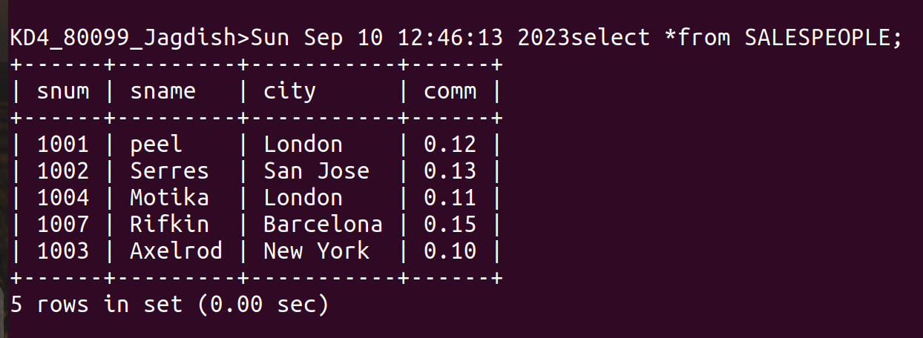
TABLE FOR CUSTOMERS

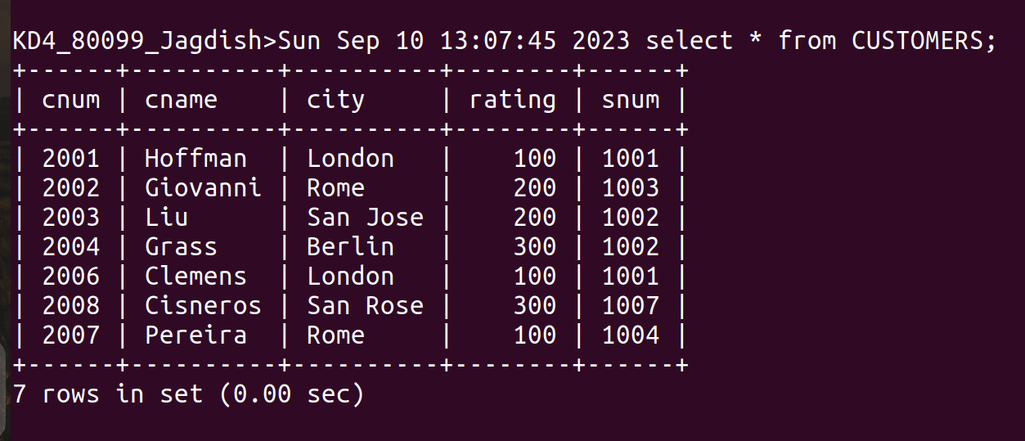

TABLE FOR ORDERS

